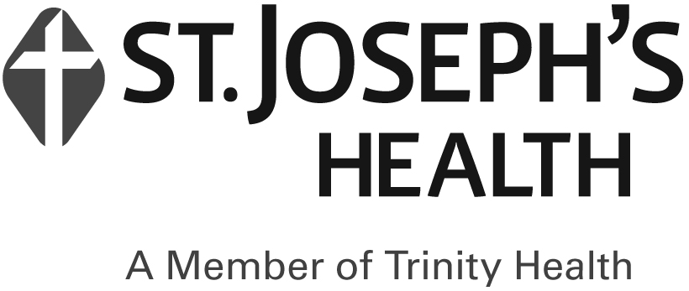
Community Health Connections Health Home
Billing Attestation Form
Staff Member Name: | ___________________________________
Care Management Agency: | ___________________________________
Billing Month: | ___________________________________

I, ______________________, or a designee from the Care Management Agency, have reviewed all billing and HML assessments and attest that:

☐ All Members identified as having a billable service for the month have a service that satisfies the CHC policies and procedures regarding billable services.

☐ All billable services provided to Members are documented in the Member’s electronic health record.

☐ All charts that are marked as billable have an active, signed Plan of Care on file, meaning the most recent Plan was updated in the previous 365 days and the Member signed that Plan electronically in CareManager or via the uploaded Member Acknowledgement Form.

☐ Documentation supporting the responses to each Member’s HML was obtained and recorded in the individual’s electronic health record.

________________________________  Staff Signature | _________________  Date

